**Spoken Tutorials - Linux Assignment**

**Indian Institute of Technology Bombay,**

**http://spoken-tutorial.org**

**File Systems**

1)Make a directory structure like this in your home directory

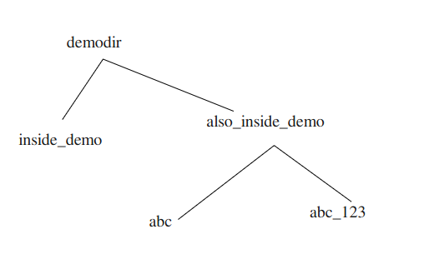

2) Remove the also_inside_demo directory

**Answers:**

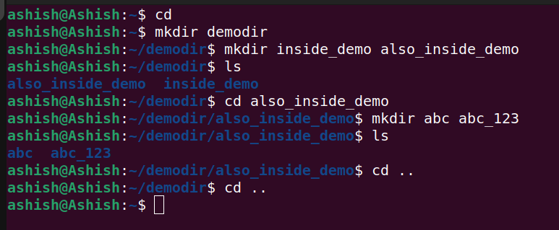

1) To create the directory “demodir”, we use mkdir demodir

command.

2) Then, we create the directories “inside_demo” and

also_inside_demo by using the-

command – mkdir inside_demo also_inside_demo.

3) Then, we move to the also_inside_dir by-

command – cd also_inside_demo

4) Then, we create the directories – abc and abc_123 by-

command – mkdir abc abc_123

To remove the also_inside_demo directory, we need to first remove its files and then, after going back to its parent dir ie, demodir, we can remove it by -

command – rmdir also_inside_123

